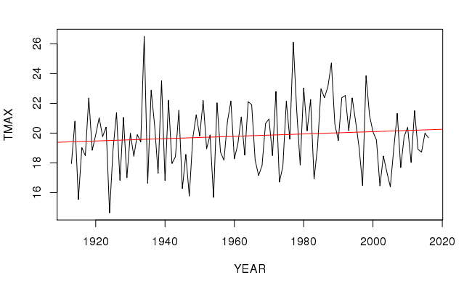

MAY MAX VALUES p-value = 0.299

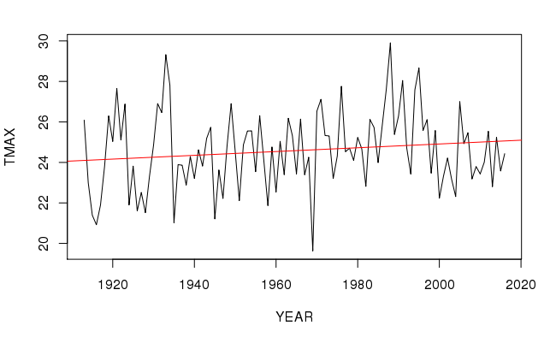

JUNE MAX VALUE p-value = 0.1373

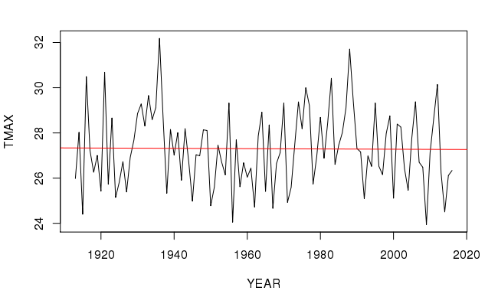

JULY MAX VALUE p-value = 0.9084

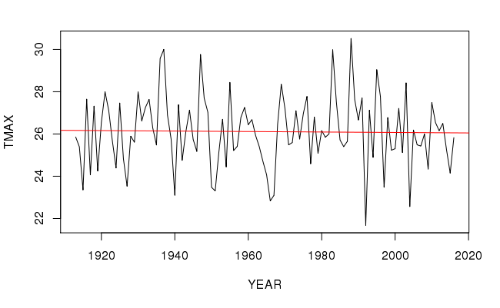

AUGUST MAX VALUES p-value = 0.8407

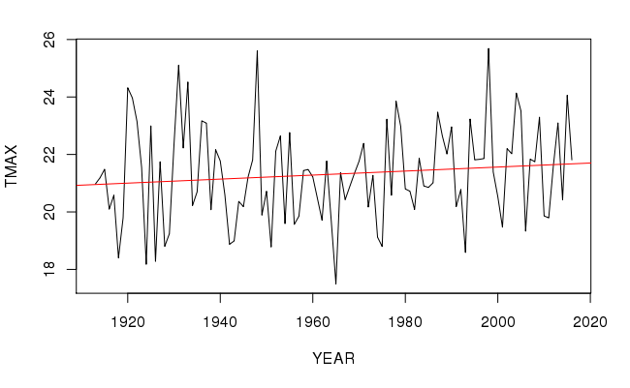

SEPTEMBER MAX VALUES p-value = 0.2061

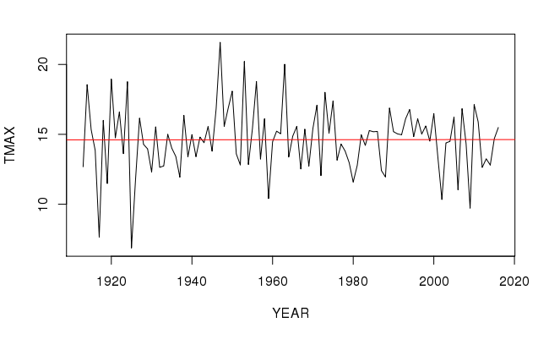

OCTOBER MAX VALUES p-value = 0.9786

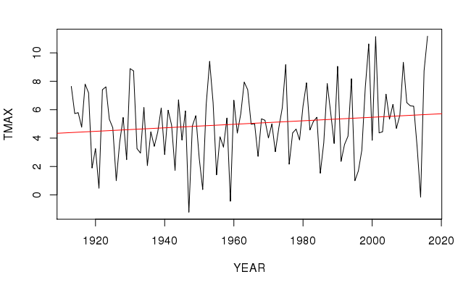

NOVEMBER MAX VALUES p-value = 0.1315

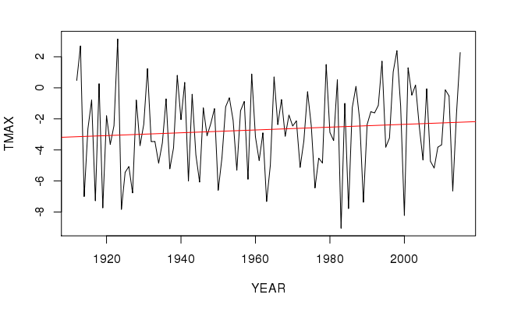

DECEMBER MAX VALUES p-value = .314

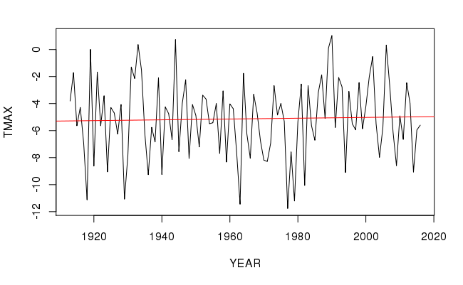

JANUARY MAX VALUES p-value = 0.7538

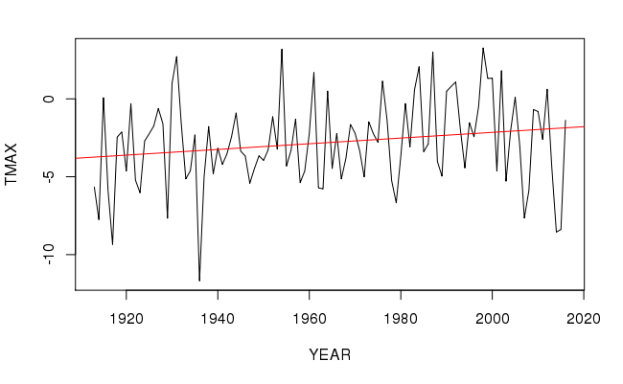

FEBRUARY MAX VALUES p-value = 0.04979

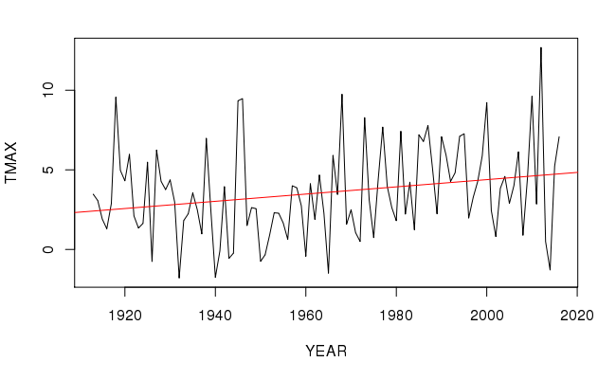

MARCH MAX VALUES p-value = 0.01595

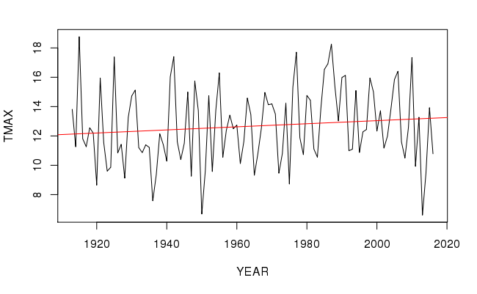

APRIL MAX VALUES p-value = 0.2193

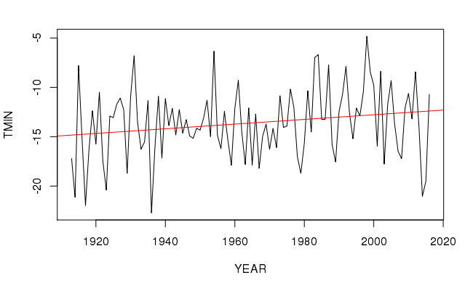

FEBRAURY MIN VALUES p-value = 0.04159

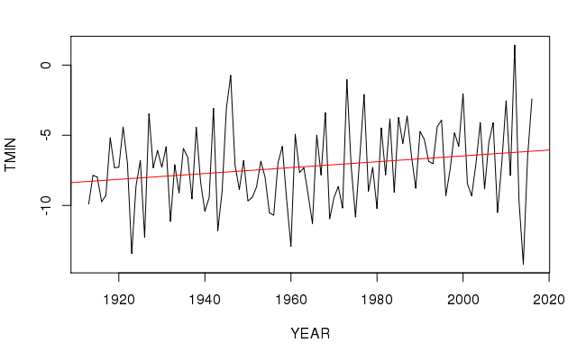

MARCH MIN VALUES p-value = 0.02517

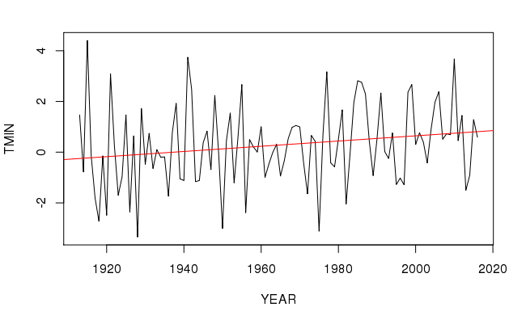

APRIL MIN VALUES p-value = 0.04453

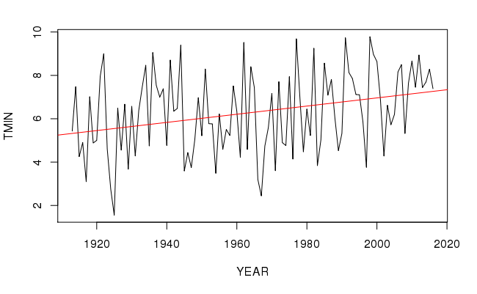

MAY MIN VALUES p-value = 0.001907

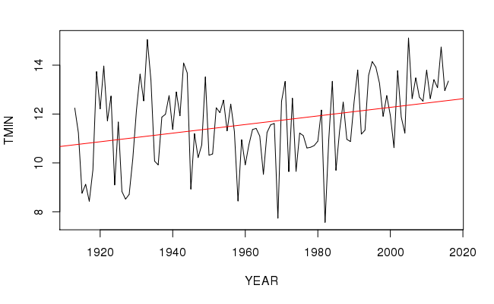

JUNE MIN VALUES p-value = 0.0009536

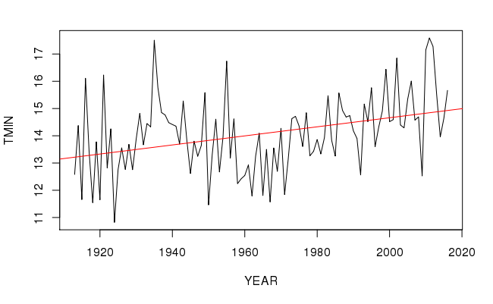

JULY MIN VALUES p-value = 0.000183

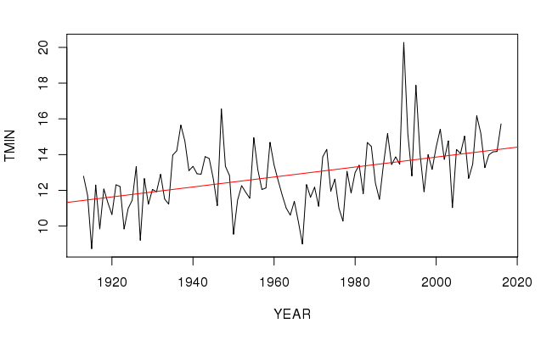

AUGUST MIN VALUES p-value = 0.000001043 🡪 1.043X10-6

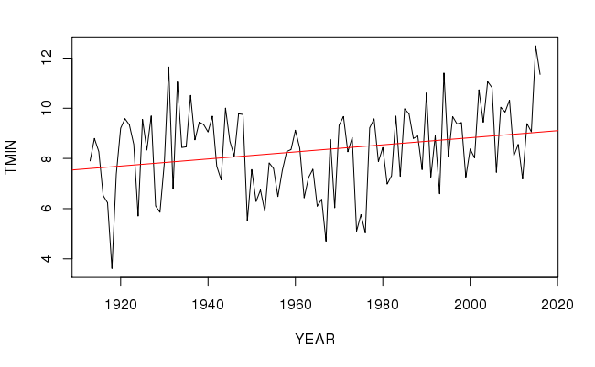

SEPTEMBER MIN VALUES p-value = 0.008791

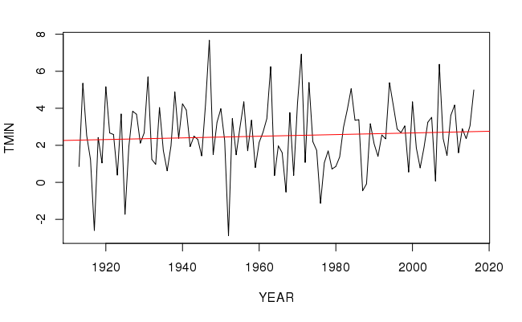

OCTOBER MIN VALUES p-value = 0.467

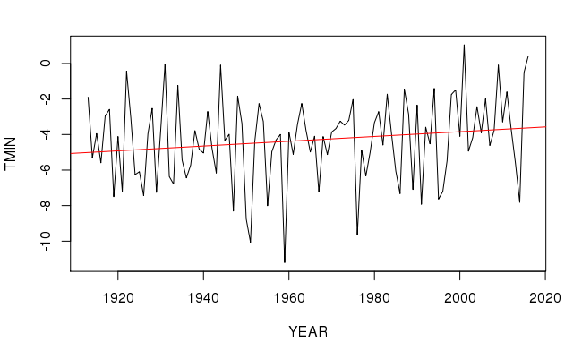

NOVEMBER MIN VALUES p-value = 0.07995

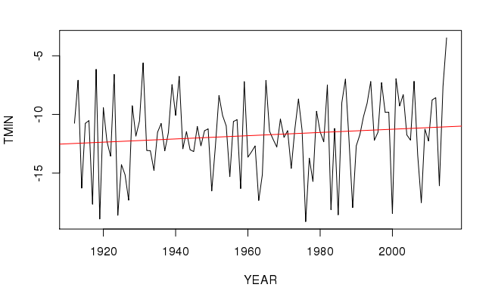

DECEMBER MIN VALUES p-value = 0.2131

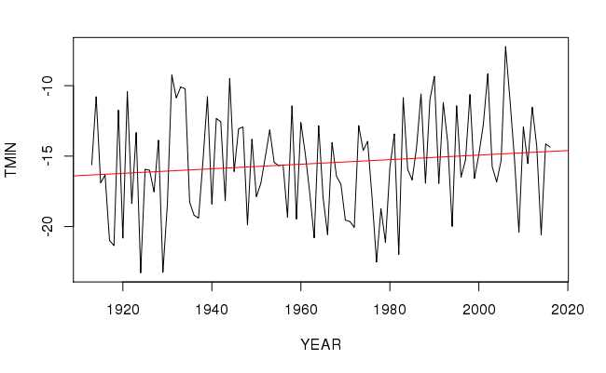

JANUARY MIN VALUES p-value = 0.1718

